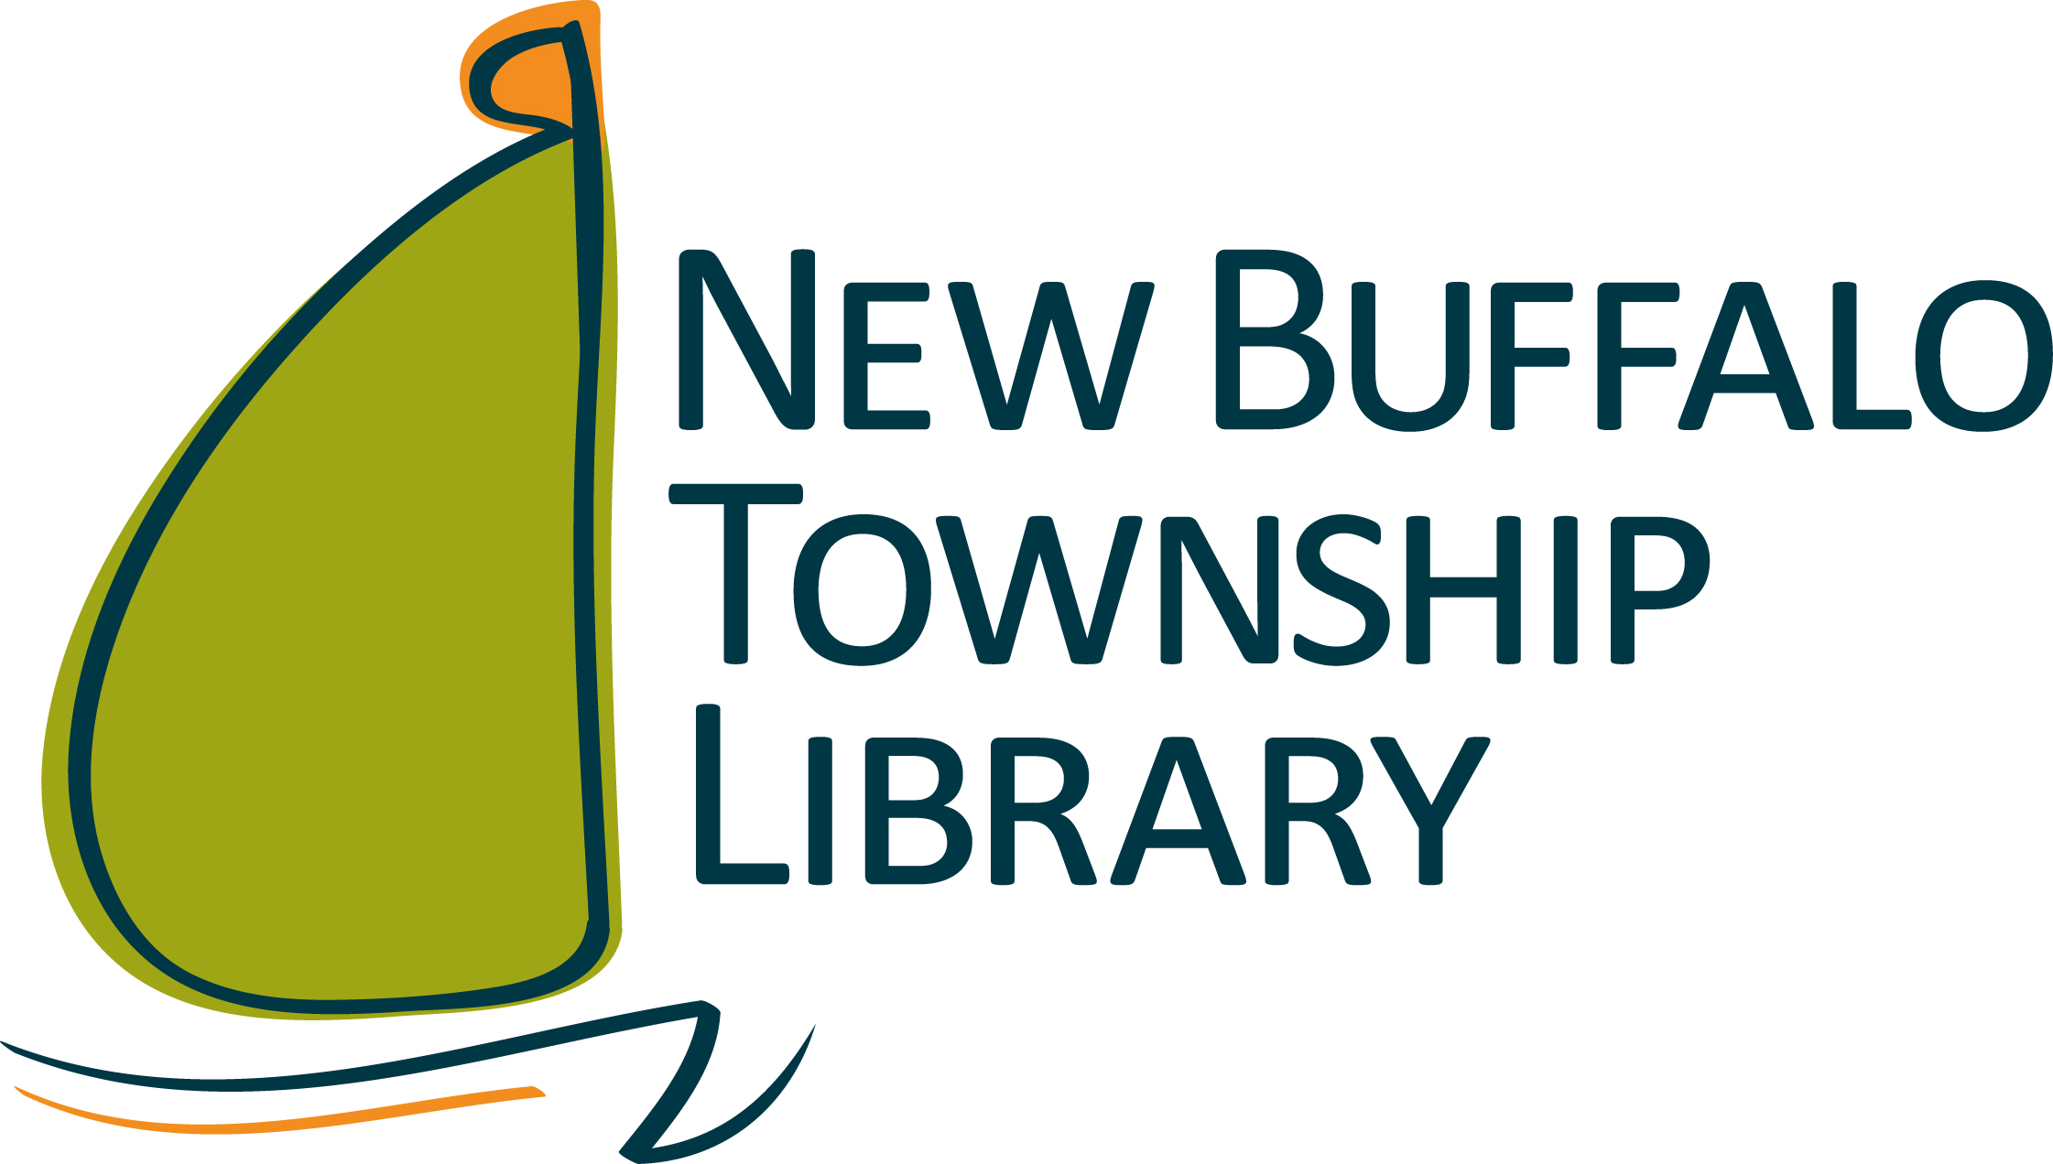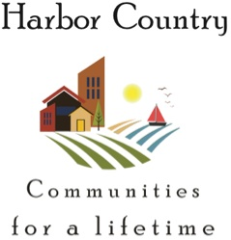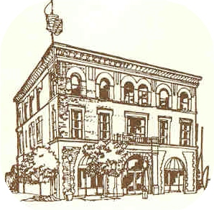

Who is Eligible?

Seniors aged 50 and older who meet certain income criteria AND live in the Harbor Country area with the following zip codes are eligible: 49115, 49116, 49117, 49125, 49128, 49129

For more information, contact

New Buffalo Township Library

Three Oaks Township Library

Application deadline November 6

Free Kindle Fire

FOR

Harbor Country Seniors

November 13, 2017

You need to possess

A Library card

An Email address

An Amazon Account